Συστήματα Αναμονής

(Queuing Systems)

3η Εργαστηριακή Άσκηση

# Λεούσης Σάββας

# Α.Μ.: 03114945

Σύγκριση συστημάτων Μ/Μ/1 και Μ/D/1

1. Ο μέσος χρόνος καθυστέρησης ενός πελάτη στην ουρά M/D/1, σύμφωνα με τον τύπο του Little, είναι $E\left(T\right)=\frac{E[n\left(t\right)]}{λ}=\frac{ρ+\frac{1}{2}\left(\frac{ρ^{2}}{1-ρ}\right)}{λ}=\frac{\frac{2ρ-2ρ^{2}+ρ^{2}}{2-2ρ}}{λ}=\frac{2ρ-ρ^{2}}{(2-2ρ)λ}=\frac{ρ(2-ρ)}{2(1-ρ)λ}$ και ο μέσος χρόνος αναμονής είναι $E\left(W\right)=E\left(T\right)-\frac{1}{μ}=\frac{ρ\left(2-ρ\right)}{2\left(1-ρ\right)λ}-\frac{1}{μ}=\frac{ρ}{2\left(1-ρ\right)μ}=\frac{ρ}{2(μ-λ)}$, ενώ η απαραίτητη συνθήκη έτσι ώστε η ουρά M/D/1 να είναι εργοδική είναι να ισχύει ότι $ρ<1⟺λ<μ.$
2. Η ζητούμενη συνάρτηση qsmd1.m είναι για ουρές M/D/1 είναι η παρακάτω:

function [U R Q X] = qsmd1( lambda, mu )

if ( nargin != 2 )

print_usage();

endif

( isvector(lambda) && isvector(mu) ) || ...

error( "lambda and mu must be vectors" );

[ err lambda mu ] = common_size( lambda, mu );

if ( err )

error( "parameters are of incompatible size" );

endif

lambda = lambda(:)';

mu = mu(:)';

all( lambda >= 0 ) || ...

error( "lambda must be >= 0" );

all( mu > lambda ) || ...

error( "The system is not ergodic" );

U = rho = lambda ./ mu; % Server utilization

R = (2-rho)./((1-rho).*mu*2); % Server response time

Q = rho./(2*(mu-lambda)); % Average number of requests in the system

X = lambda; % Server throughput

endfunction

1. Χρησιμοποιώντας τις συναρτήσεις qsmm1 και qsmd1, προκύπτουν οι παρακάτω γραφικές παραστάσεις:

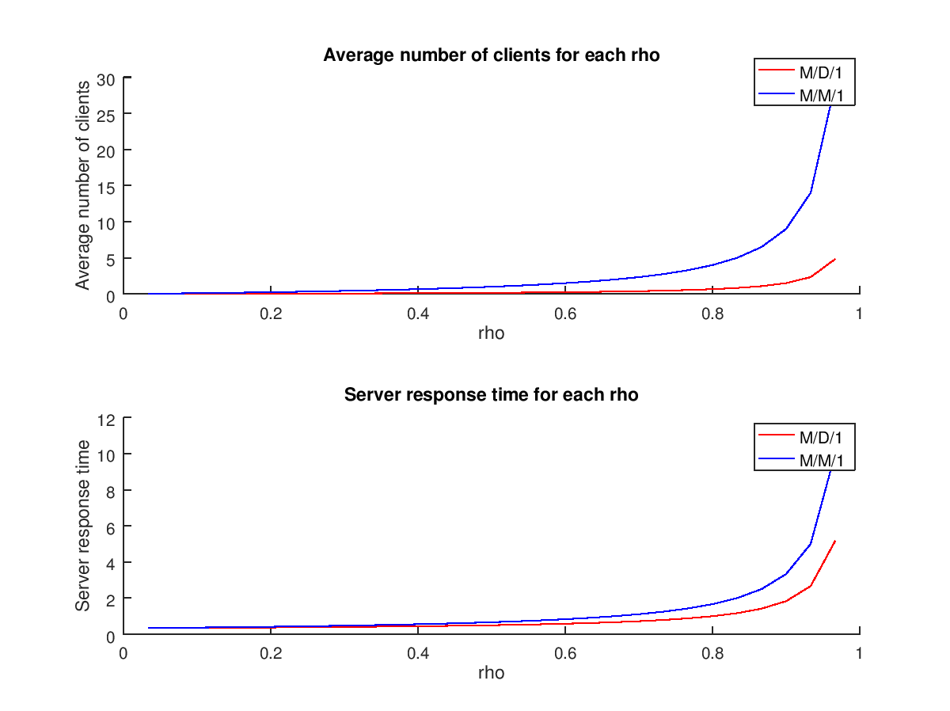

Παρατηρώντας τις παραπάνω γραφικές παραστάσεις, βλέπουμε ότι από τις δύο ουρές τόσο ο μέσος αριθμός πελατών στο σύστημα, όσο και ο μέσος χρόνος καθυστέρσης είναι σαφώς μικρότεροι για την ουρά M/D/1. Επομένως, η ουρά M/D/1 είναι το καλύτερο σύστημα από τα δύo.

# Προσομοίωση συστήματος Μ/Μ/1/10

# Η ζητούμενος κώδικας προσωμοίωσης ενός συστήματος Μ/Μ/1/10 είναι ο παρακάτω:

# lambda = [1,5,10];

# mu = 5;

# for lambda = [1,5,10]

# total_arrivals = 0; % to measure the total number of arrivals

# current_state = 0; % holds the current state of the system

# previous_mean_clients = 0; % will help in the convergence test

# index = 0;

# clear arrivals;

# clear P;

# display(lambda);

# threshold = lambda/(lambda + mu); % the threshold used to calculate probabilities

# rand("seed",1);

# transitions = 0; % holds the transitions of the simulation in transitions steps

# while transitions >= 0

# transitions = transitions + 1; % one more transitions step

# 

# if mod(transitions,1000) == 0 % check for convergence every 1000 transitions steps

# index = index + 1;

# for i=1:1:length(arrivals)

# P(i) = arrivals(i)/total_arrivals; % calculate the probability of every state in the system

# endfor

# P_blocking = P(length(arrivals));

# mean_clients = 0; % calculate the mean number of clients in the system

# for i=1:1:length(arrivals)

# mean_clients = mean_clients + (i-1).*P(i);

# endfor

# 

# to_plot(index) = mean_clients;

# 

# if abs(mean_clients - previous_mean_clients) < 0.00001 || transitions > 1000000 % convergence test

# break;

# endif

# 

# previous_mean_clients = mean_clients;

# 

# endif

# 

# random_number = rand(1); % generate a random number (Uniform distribution)

# # if (transitions<=30) % debugging

# # display("##### NEW TRANSITION #####");

# # display(transitions);

# # display(current_state);

# # if current_state == 0 || random_number < threshold

# # display("Next transition is an arrival.");

# # else

# # display("Next transition is a departure.");

# # endif

# # display(total_arrivals);

# # endif

# if current_state == 0 || random_number < threshold % arrival

# total_arrivals = total_arrivals + 1;

# try % to catch the exception if variable arrivals(i) is undefined. Required only for systems with finite capacity.

# arrivals(current_state + 1) = arrivals(current_state + 1) + 1; % increase the number of arrivals in the current state

# catch

# arrivals(current_state + 1) = 1;

# end

# if current_state == 10

# continue;

# else

# current_state = current_state + 1;

# endif

# else % departure

# if current_state != 0 % no departure from an empty system

# current_state = current_state - 1;

# endif

# endif

# endwhile

# for i=1:1:length(arrivals)

# display(P(i));

# endfor

# display(P_blocking);

# figure(fig_num++);

# plot(to_plot,"r","linewidth",1.3);

# title("Average number of clients in the M/M/1/10 queue: Convergence");

# xlabel("transitions in thousands");

# ylabel("Average number of clients");

# figure(fig_num++);

# bar(P,'r',0.4);

# title("Probabilities");

# endfor

# Για κάθε τιμή του λ προέκυψαν οι παρακάτω γραφικές παραστάσεις των εργοδικών πιθανοτήτων καθώς και της εξέλιξης του μέσου αριθμού πελατών στο σύστημα ανά 1000 μεταβάσεις:

# λ=1

# 

# 

# λ=5

# 

# λ=10

# 

# 

# Σύμφωνα με τις παραπάνω γραφικές παραστάσεις, παρατηρούμε ότι όσο αυξάνεται το λ, τόσο αυξάνεται ο απαιτούμενος αριθμός μεταβάσεων έτσι ώστε το σύστημα να ικανοποιήσει το κριτήριο σύγκλισης. Προκειμένου να επιταχυνθεί η προσωμοίωση, θα μπορούσαμε να αγνοήσουμε τουλάχιστον 40.000 αρχικές μεταβάσεις, καθώς για τη σύγκλιση μας ενδιαφέρει η μόνιμη κατάσταση του συστήματος.

# Προσομοίωση συστήματος Μ/Μ/1/5

# με μεταβλητό μέσο ρυθμό εξυπηρέτησης

# Οι εργοδικές πιθανότητες του συστήματος με τη βοήθεια του πακέτου queueing του Octave είναι οι εξής:

# 

1. Τα ζητούμενα αποτελέσματα της προσωμοίωσης για την κάθε τιμή του κριτηρίου τερματισμού είναι τα παρακάτω:
   1. 1%

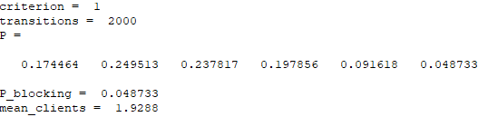

* 1. 0.1%

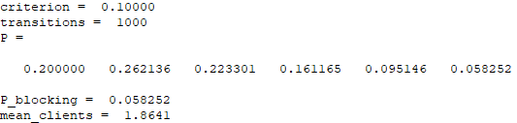

* 1. 0.01%

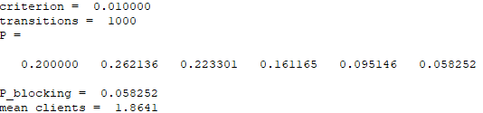

* 1. 0.001%

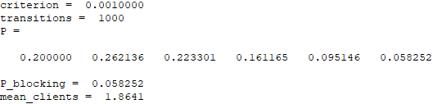

* 1. 0.0001%

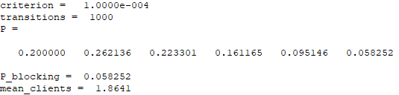

* 1. 0.00001%

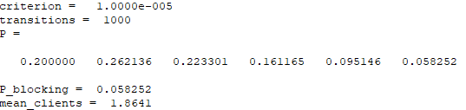

* 1. 0.000001%

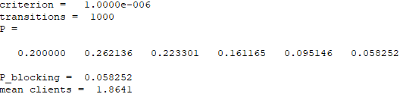

* 1. 0.0000001%

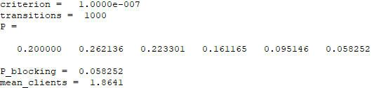

# Παράρτημα (κώδικας Lab3.m)

clc;

clear all;

close all;

fig_num = 1;

############# M/M/1 AND M/D/1 SYSTEMS COMPARISON #############

# 3

lambda=0.1:0.1:2.9;

mu=[3];

[UD RD QD XD] = qsmd1(lambda,mu);

[UM RM QM XM p0] = qsmm1(lambda,mu);

figure(fig_num++);

subplot(2,1,1);

hold on;

plot(lambda./mu,QD,"r");

plot(lambda./mu,QM,"b");

hold off;

title("Average number of clients for each rho");

xlabel("rho");

ylabel("Average number of clients");

legend("M/D/1","M/M/1");

subplot(2,1,2);

hold on;

plot(lambda./mu,RD,"r");

plot(lambda./mu,RM,"b");

hold off;

title("Server response time for each rho");

xlabel("rho");

ylabel("Server response time");

legend("M/D/1","M/M/1");

############# M/M/1/10 SYSTEM SIMULATION #############

lambda = [1,5,10];

mu = 5;

for lambda = [1,5,10]

total_arrivals = 0; % to measure the total number of arrivals

current_state = 0; % holds the current state of the system

previous_mean_clients = 0; % will help in the convergence test

index = 0;

clear arrivals;

clear P;

display(lambda);

threshold = lambda/(lambda + mu); % the threshold used to calculate probabilities

rand("seed",1);

transitions = 0; % holds the transitions of the simulation in transitions steps

while transitions >= 0

transitions = transitions + 1; % one more transitions step

if mod(transitions,1000) == 0 % check for convergence every 1000 transitions steps

index = index + 1;

for i=1:1:length(arrivals)

P(i) = arrivals(i)/total_arrivals; % calculate the probability of every state in the system

endfor

P_blocking = P(length(arrivals));

mean_clients = 0; % calculate the mean number of clients in the system

for i=1:1:length(arrivals)

mean_clients = mean_clients + (i-1).*P(i);

endfor

to_plot(index) = mean_clients;

if abs(mean_clients - previous_mean_clients) < 0.00001 || transitions > 1000000 % convergence test

break;

endif

previous_mean_clients = mean_clients;

endif

random_number = rand(1); % generate a random number (Uniform distribution)

# if (transitions<=30) % debugging

# display("##### NEW TRANSITION #####");

# display(transitions);

# display(current_state);

# if current_state == 0 || random_number < threshold

# display("Next transition is an arrival.");

# else

# display("Next transition is a departure.");

# endif

# display(total_arrivals);

# endif

if current_state == 0 || random_number < threshold % arrival

total_arrivals = total_arrivals + 1;

try % to catch the exception if variable arrivals(i) is undefined. Required only for systems with finite capacity.

arrivals(current_state + 1) = arrivals(current_state + 1) + 1; % increase the number of arrivals in the current state

catch

arrivals(current_state + 1) = 1;

end

if current_state == 10

continue;

else

current_state = current_state + 1;

endif

else % departure

if current_state != 0 % no departure from an empty system

current_state = current_state - 1;

endif

endif

endwhile

for i=1:1:length(arrivals)

display(P(i));

endfor

display(P_blocking);

figure(fig_num++);

plot(to_plot,"r","linewidth",1.3);

title("Average number of clients in the M/M/1/10 queue: Convergence");

xlabel("transitions in thousands");

ylabel("Average number of clients");

figure(fig_num++);

bar(P,'r',0.4);

title("Probabilities");

endfor

############# M/M/1/5 SYSTEM SIMULATION WITH VARIABLE MU #############

# 1

states = [0,1,2,3,4,5];

initial_state = [1,0,0,0,0,0];

lambda = 3;

mu = 1;

births_B = [lambda,lambda,lambda,lambda,lambda];

deaths_D = [mu*2,mu*3,mu*4,mu*5,mu*6];

transition_matrix = ctmcbd(births_B,deaths_D);

P = ctmc(transition_matrix);

for i=[1,2,3,4,5,6]

index = 0;

for T=0:0.01:50

index = index + 1;

P0 = ctmc(transition_matrix,T,initial_state);

Prob0(index) = P0(i);

if P0-P < 0.01

break;

endif

endfor

endfor

display(P0);

# 2

lambda = 3;

mu = [1,2,3,4,5,6];

for criterion = [1,0.1,0.01,0.001,0.0001,0.00001,0.000001,0.0000001]

total_arrivals = 0; % to measure the total number of arrivals

current_state = 0; % holds the current state of the system

previous_mean_clients = 0; % will help in the convergence test

index = 0;

clear arrivals;

clear P;

rand("seed",1);

transitions = 0; % holds the transitions of the simulation in transitions steps

while transitions >= 0

threshold = lambda/(lambda + current_state + 1);

transitions = transitions + 1; % one more transitions step

if mod(transitions,1000) == 0 % check for convergence every 1000 transitions steps

index = index + 1;

for i=1:1:length(arrivals)

P(i) = arrivals(i)/total_arrivals; % calculate the probability of every state in the system

endfor

P_blocking = P(length(arrivals));

mean_clients = 0; % calculate the mean number of clients in the system

for i=1:1:length(arrivals)

mean_clients = mean_clients + (i-1).*P(i);

endfor

to_plot(index) = mean_clients;

if abs(mean_clients - previous_mean_clients) < 1/criterion || transitions > 1000000 % convergence test

display(criterion);

display(transitions);

break;

endif

previous_mean_clients = mean_clients;

endif

random_number = rand(1); % generate a random number (Uniform distribution)

if current_state == 0 || random_number < threshold % arrival

total_arrivals = total_arrivals + 1;

try % to catch the exception if variable arrivals(i) is undefined. Required only for systems with finite capacity.

arrivals(current_state + 1) = arrivals(current_state + 1) + 1; % increase the number of arrivals in the current state

catch

arrivals(current_state + 1) = 1;

end

if current_state == 5

continue;

else

current_state = current_state + 1;

endif

else % departure

if current_state != 0 % no departure from an empty system

current_state = current_state - 1;

endif

endif

endwhile

display(P);

display(P_blocking);

display(mean_clients);

endfor